COIT20245- Introduction to Programming
Assignment 2-Term 2, 2019

Lecturer: Ahmedi Azra
Tutor: Aries Tao

Prepared By:
Bishal Budhathoki
12116421
UML ACTIVITY DIAGRAM OF OPTION 2:
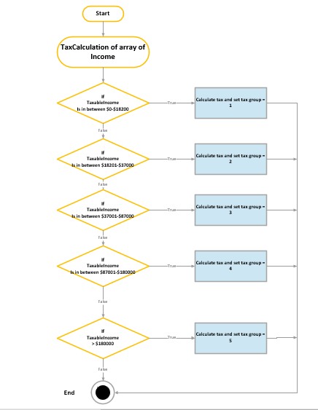
Figure 1: UML Activity diagram for menu option 2

Output:
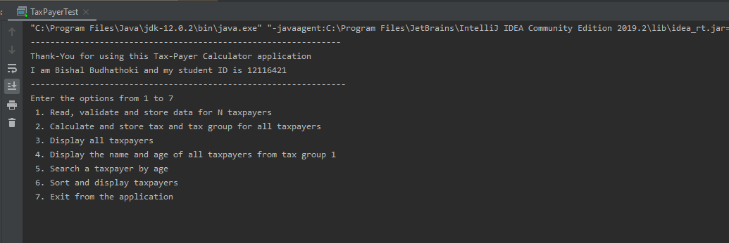
Figure 2: Welcome Message

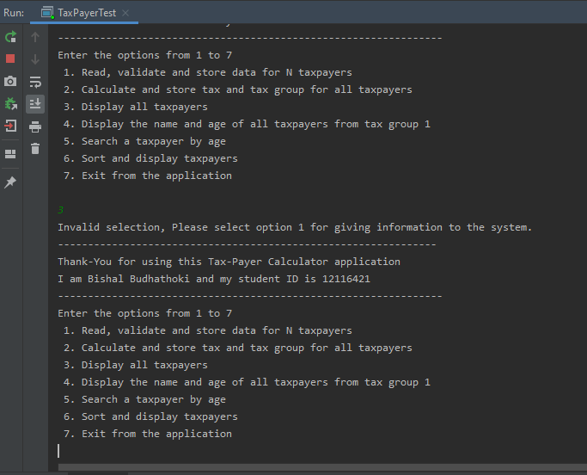
Figure 3: Error message when entering another option different than 1 at beginning

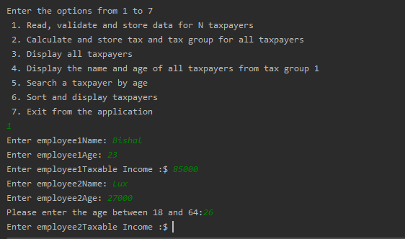
Figure 4: Age entered wrong and is handled with an error message

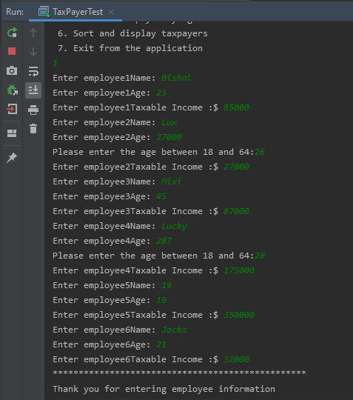
Figure 5: User input read and stored in array

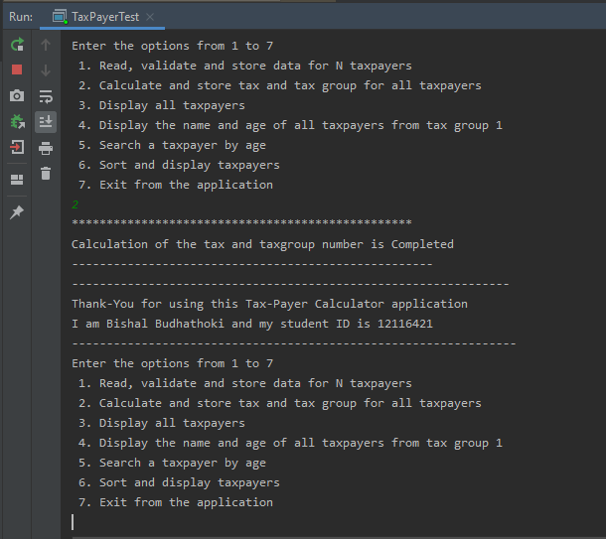
Figure 6: Calculation of tax and tax group number when option 2 is selected

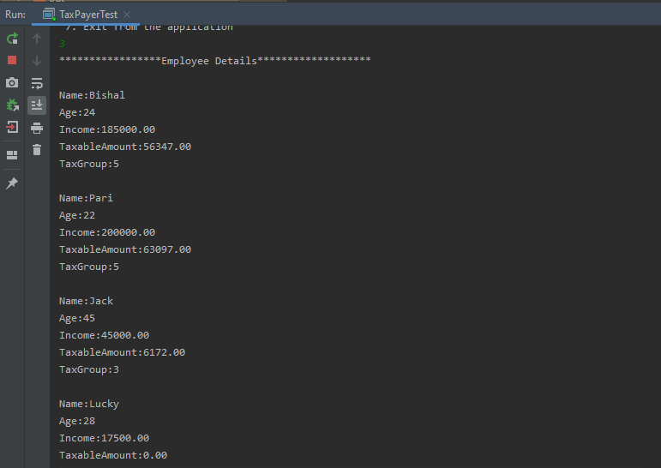
Figure 7: Display user input along with their tax group when option 3 is selected

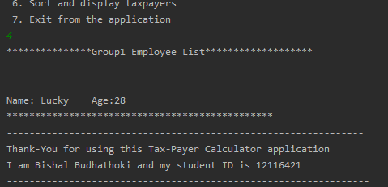
Figure 8: Display group 1 Name and age data when option 4 is selected

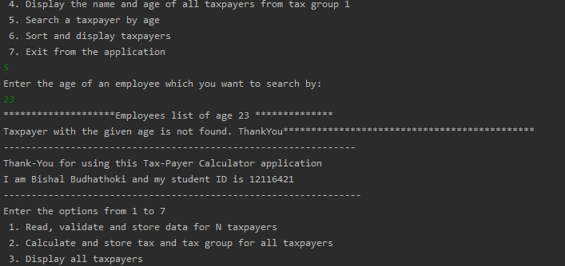
Figure 9: Search taxpayer by age but not found when option 5 is selected

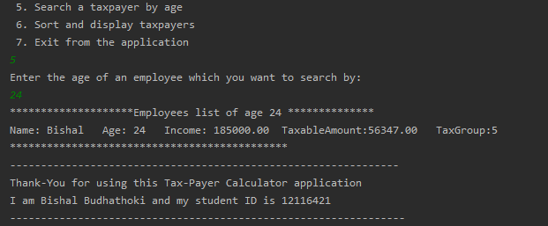
Figure 10: Search taxpayer by age and found when option 5 is selected

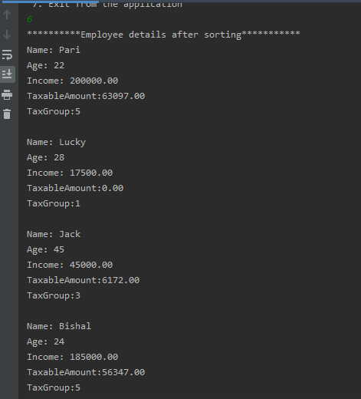
Figure 11: Sort and display the user input taxpayer in descending order of name when option 6 is selected

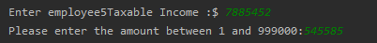
Figure 12: Display message to provide correct taxable income amount

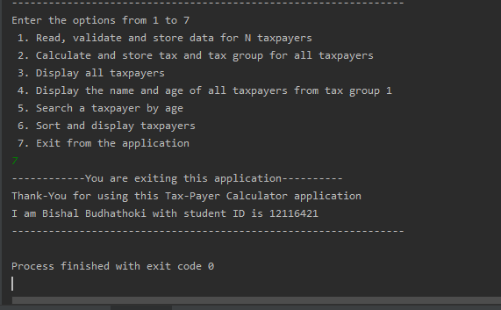
Figure 13: Display exit message

Thank-You

